Ex.No. : 3
Date:

DML Commands – INSERT, SELECT, UPDATE, DELETE

Aim:

To perform Data Manipulation Language (DML) Commands such as INSERT, SELECT, UPDATE, DELETE in the table.

Description:

Data Manipulation Language (DML) statements are used for managing data within schema objects. DML Commands: Insert , Update, Delete, Select

  - INSERT - insert data into a table
  - UPDATE - updates existing data within a table

- • DELETE - deletes all records from a table, the space for the records remain

  - SELECT - retrieve data from the a database

INSERT:

INSERT INTO table_name
VALUES (value1, value2, value3,...);

( or )

INSERT INTO table_name (column1, column2, column3,...)
VALUES (value1, value2, value3,...);

UPDATE:

UPDATE table_name

SET column1=value, column2=value2,...
WHERE some_column=some_value;

DELETE:

DELETE FROM table_name

WHERE some_column=some_value;

SELECT:

SELECT column_name(s)

FROM table_name;

Questions:

- Populate all the five tables with your own data.

- Update the value of student name whose register number is ‘191711342’

- Delete the record in the table FACULTY, who resigned her job.

- Modify the date of birth for the faculty whose name is 'RAM' with a value ‘1983-05-01’.

- Remove all faculty who are having over 65 years

- View all the records from the five tables. Exercise

OUTPUTS:

1) 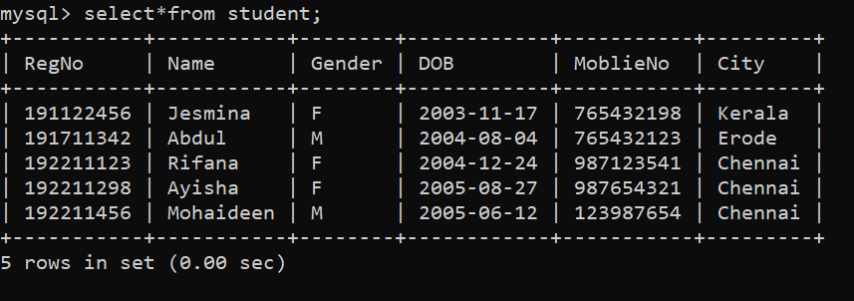

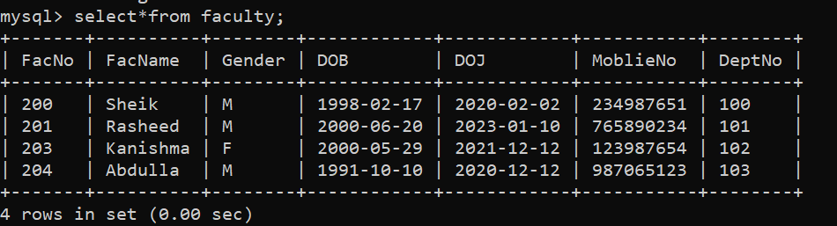

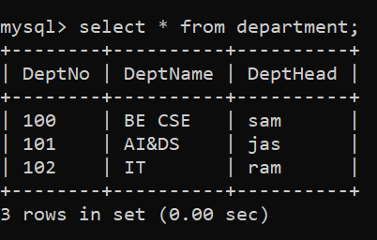

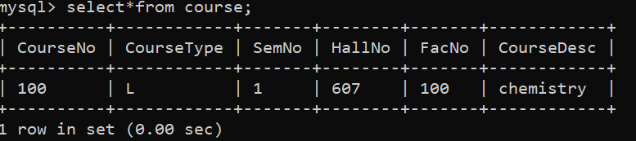

2)

3)

4)

5)

6)

RESULT:

Data Manipulation Language (DML) Commands such as INSERT, SELECT, UPDATE, DELETE are performed in the five tables.

16-DATABASE MANAGEMENT SYSTEMS

